***Oracle Database 23ai Free Installation Guide for Windows***

This guide outlines the steps for installing the Oracle Database 23ai Free platform on a Windows system.

**Installation Steps**

1. **Download the ZIP File**
   * 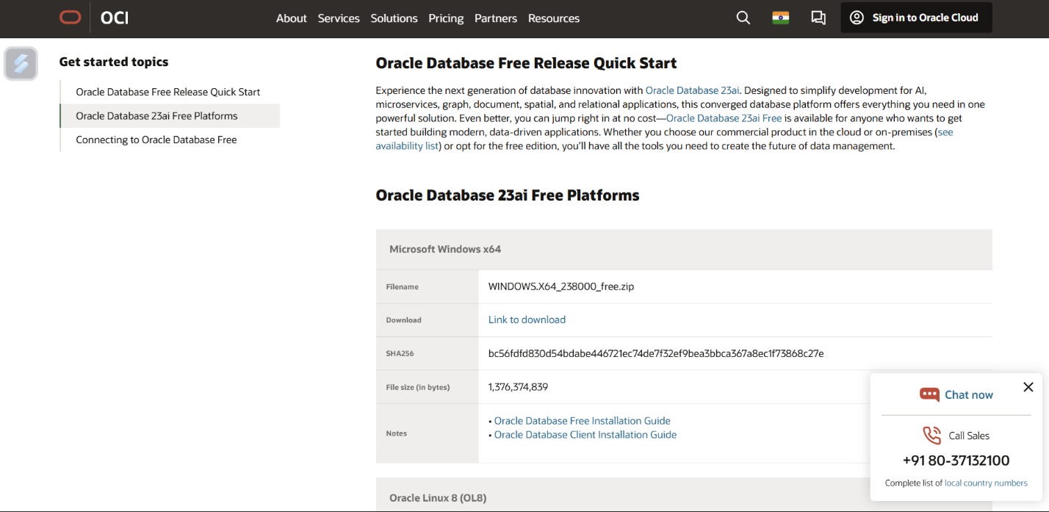Visit the Oracle Home Page and download the ZIP file for the Windows x64 platform. The direct link is provided as [https://www.oracle.com/in/database/free/get-started/#windows](https://www.oracle.com/in/database/free/get-started/#windows2).
2. **Extract the ZIP File**
   * 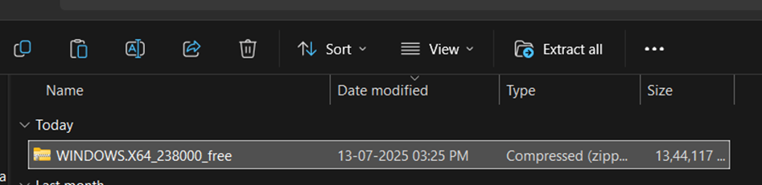Locate the downloaded ZIP file and **extract all** its contents.
3. **Run Setup as Administrator**
   * 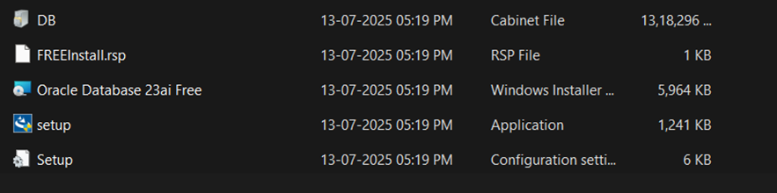Open the extracted folder and run the **setup** **via Run As Administrator.**
4. 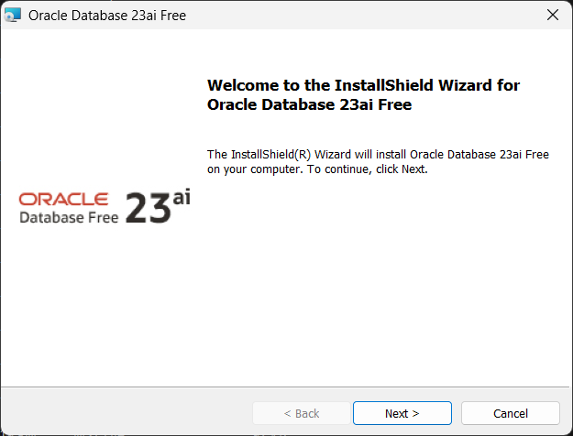**Proceed through the InstallShield Wizard**
5. **Accept the License Agreement**
   * Read the **Oracle Free Use Terms and Conditions**.
   * 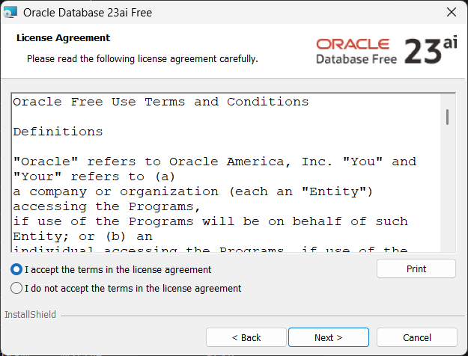Select **I accept the terms in the license agreement"** and click **Next** to proceed.
6. **Select Destination Folder**
   * The wizard will show the default **Destination Folder** for the installation. You can use the default or click "Change..." to select a different location.
   * Click **Next**.

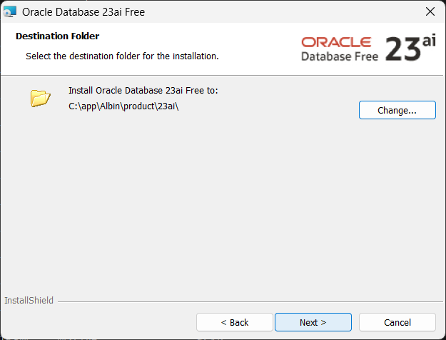

1. **Set Database Password**
   * Specify a database password for the **SYS, SYSTEM, and PDBADMIN accounts**.
   * **Enter Database Password** and **Confirm Database Password**.
   * 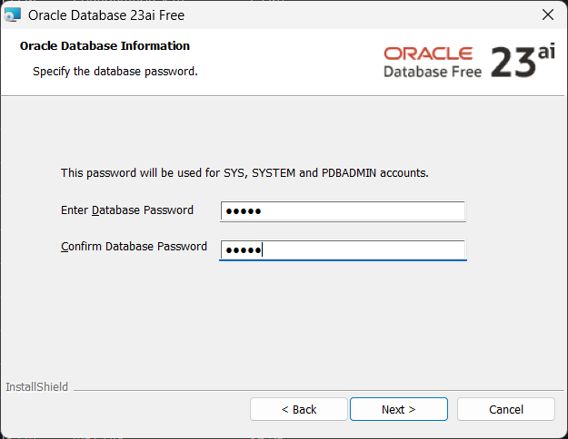Click **Next.**
2. **Begin Installation**
   * Review the **Summary** screen, which lists the **Destination Folder**, **Oracle Home**, and **Oracle Base**.
   * Click **Install** to begin the installation.

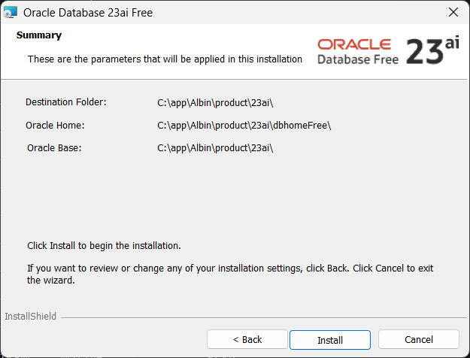

1. 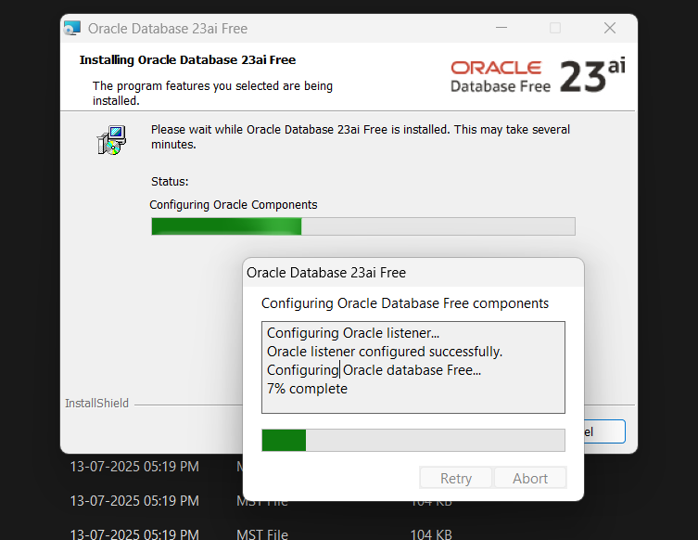**Wait for Installation to Finish**. **This may take several minutes**.
2. **Installation Complete**
   * Once it is installled successfully, click **Finish** to exit the wizard.

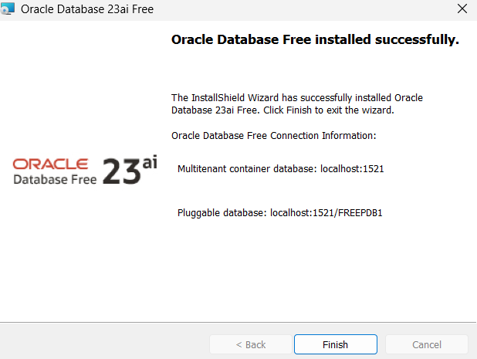

**Checking Connection Status**

To verify the successful installation and connection of your database, you can use the Command Prompt:

1. **Check Oracle Services**
   * Open **Command Prompt as Administrator**.
   * Run the command: **sc query | findstr /i "oracle”**
   * You should see both the **OracleOraDB23Home1TNSListener** and **OracleServiceFREE** .
2. **Connect with SQL*Plus**
   * In the Command Prompt, run: **sqlplus /nolog**.
   * Once in the SQL prompt, run: **CONNECT SYS AS SYSDBA**.
   * **Enter the password** you set in Step 7. The output should show "**Connected.**".
3. **Check Instance Status**
   * In the SQL prompt, run the command: **SELECT INSTANCE_NAME, STATUS, DATABASE_STATUS FROM V$INSTANCE;**
   * 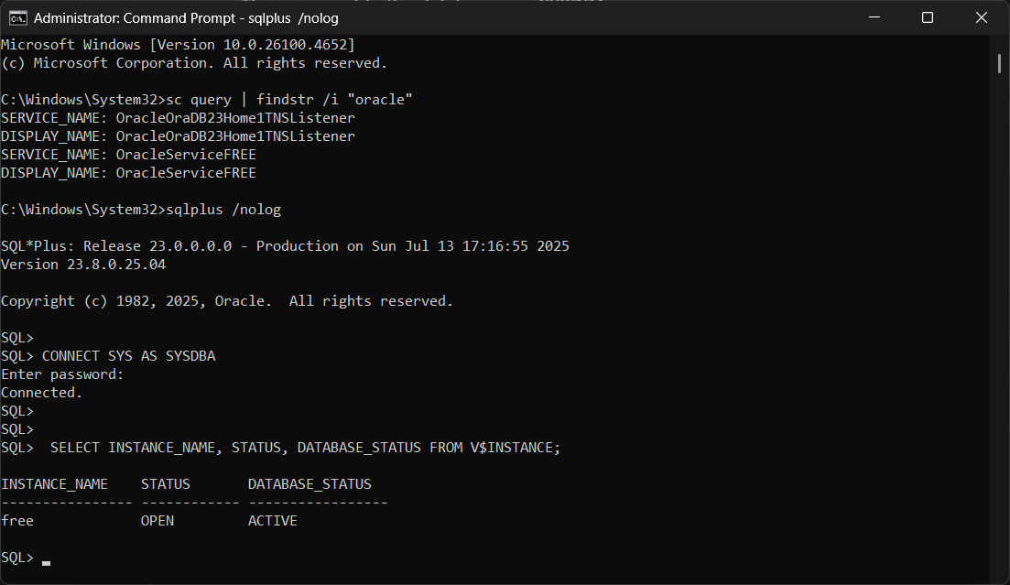The output for the instance named **free** should show **STATUS** as **OPEN** and **DATABASE_STATUS** as **ACTIVE**.